**Catalog**

A. ESP-IDF compiler download 2

1.1 Software environment description 2

1.2 Installation dependencies 2

1.3 Download SDK 2

1.4 Install the compilation tool chain 3

B. Use cmd to run CSI cases 4

2.1 Download esp-csi project 4

2.2 Compile the project files 4

2.2.1 Add environment variables 4

2.2.2 Configure menuconfig 5

2.2.3 Choose chip 6

2.2.4 Compile and debug 6

2.2.5 Download firmware 6

2.2.6 Open the serial port 7

2.3 Run CSI 7

2.3.1 AP mode setting 7

2.3.2 Station mode setting 8

2.3.3 Print CSI log 9

# A. ESP-IDF compiler download

## 1.1 Software environment description

* Applicable system: Windows10 64-bit version
* Installation version: ESP-DIF v4.3
* Build system: CMake

## 1.2 Installation dependencies

* Install python3.7

Download link : <https://www.python.org/ftp/python/3.7.9/python-3.7.9-amd64.exe>

Need to add environment variables after installation.

Modify pip source：

pip config set global.index-url http://mirrors.aliyun.com/pypi/simple

pip config set global.trusted-host mirrors.aliyun.com

* Install Git

Git is used to pull ESP-IDF source code, code version control, etc.

Download link : <https://github.com/git-for-windows/git/releases/download/v2.30.0.windows.1/Git-2.30.0-64-bit.exe>

## 1.3 Download SDK

* Create a directory to store the SDK, right-click in the blank space of the directory, and click “Git Bash Here”.
* Download the redirection script esp-gitee-tools and execute the following command :

git clone https://gitee.com/EspressifSystems/esp-gitee-tools.git

* Download SDK

git clone https://gitee.com/EspressifSystems/esp-idf.git

cd esp-idf

git checkout 6e776946d01ec0d081d09000c36d23ec1d318c06

**Notes：**CSI cases must use this version number by default.

* Use esp-gitee-tools to pull submodules

cd esp-gitee-tools

export EGT_PATH=$(pwd)

cd ..

cd esp-idf

$EGT_PATH/submodule-update.sh

## 1.4 Install the compilation tool chain

* Enter the directory and open the Git terminal window
* Use esp-gitee-tools to install the compilation tool chain and execute the following commands :

cd esp-gitee-tools

export EGT_PATH=$(pwd)

cd ..

cd esp-idf

$EGT_PATH/install.sh

# B. Use cmd to run CSI cases

## 2.1 Download esp-csi project

* Enter the esp-idf dictionory，open the Git terminal window and execute the following commands :

cd examples

git clone https://github.com/espressif/esp-csi.git

## 2.2 Compile the project files

Enter the SDK directory, use cmd to open the command line.

### 2.2.1 Add environment variables

Run export.bat in the esp-idf directory to add environment variables to the current terminal.

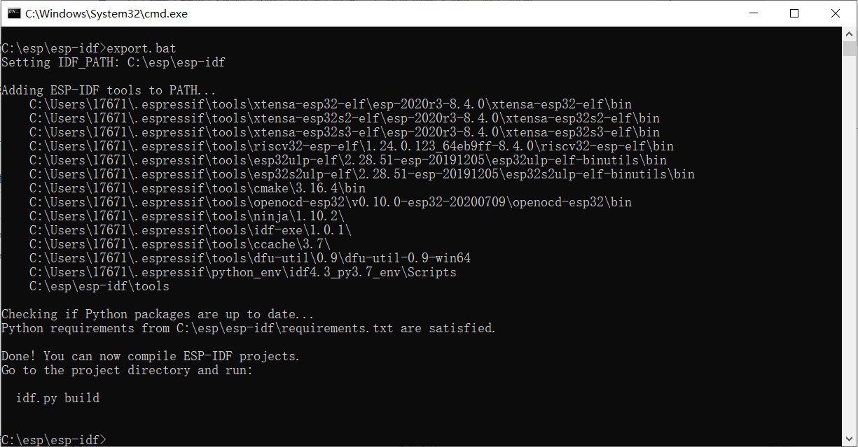

**Notes：**It should be noted that in some cases, some environment variables may not be added. It is recommended to run export.bat twice every time you run export.bat, and run this script every time you open cmd to add environment variables to the current terminal to compile esp-idf.

### 2.2.2 Configure menuconfig

cd examples/esp-csi-master/examples/console_test

pip install windows-curses

# This command is used to install third-party repositories

idf.py menuconfig

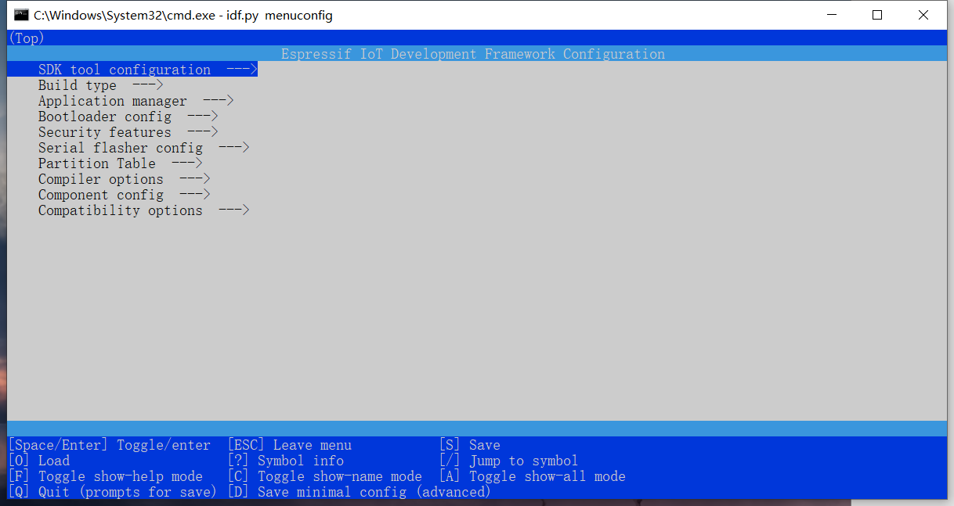

Here we configure the macro, baud rate, flash mode, flash size and speed and other information we need.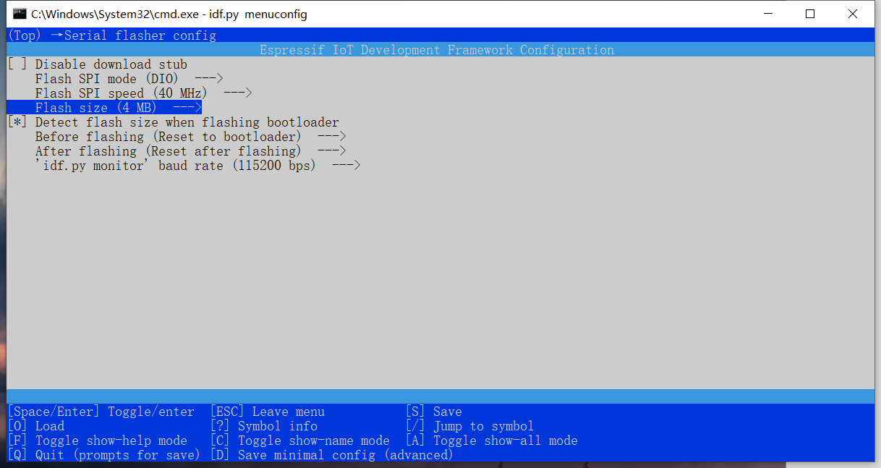

### 2.2.3 Choose chip

Here we choose ESP32 module.

idf.py set-target esp32

### 2.2.4 Compile and debug

idf.py build

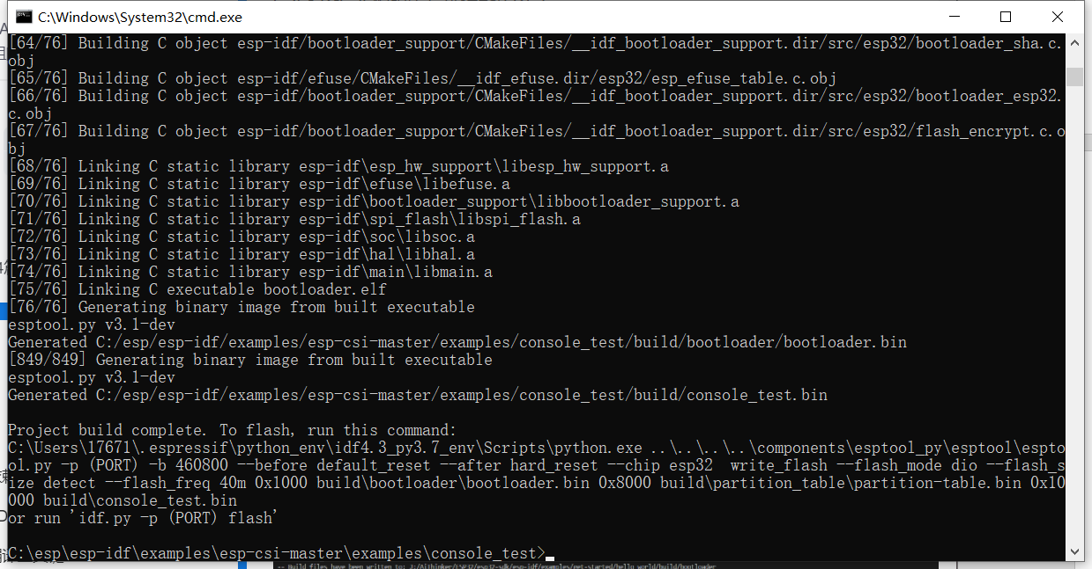

### 2.2.5 Download firmware

idf.py -p COM erase_flash

idf.py -p COM flash

**Notes**：COM is the serial port number of the module, check the port number of the computer to get it.

### 2.2.6 Open the serial port

idf.py -p COM monitor

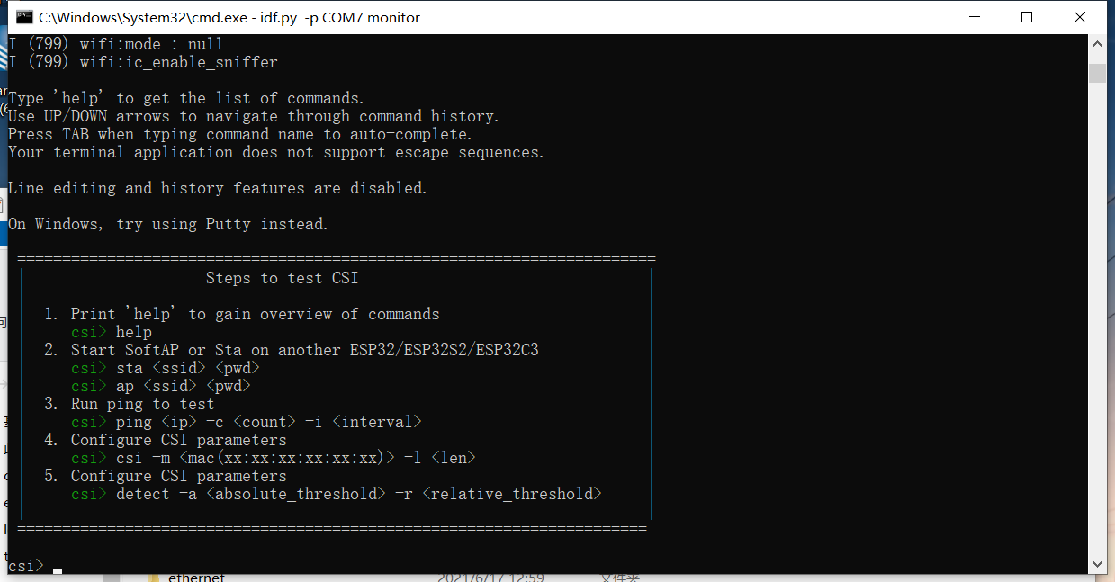

## 2.3 Run CSI

This case requires two ESP32 modules, one for AP, one for Station, and Station is to receive CSI information.

### 2.3.1 AP mode setting

csi >ap csi_softap

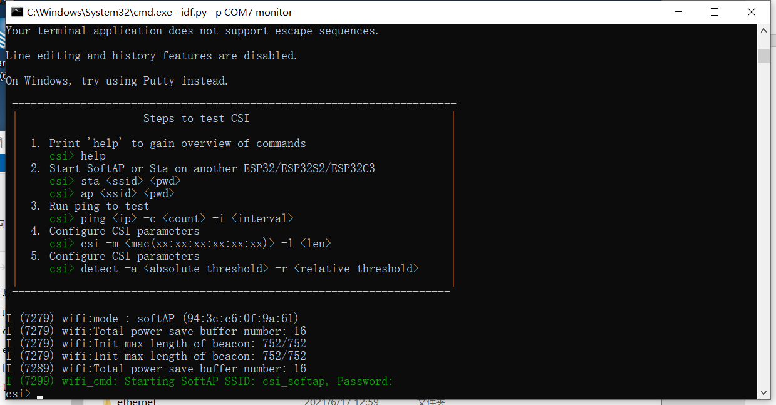

### 2.3.2 Station mode setting

Reopen a cmd window in the SDK directory and run to the end of 2.2.6.

Enter Ctrl+T to open the interface and Ctrl+L to open the log acquisition.

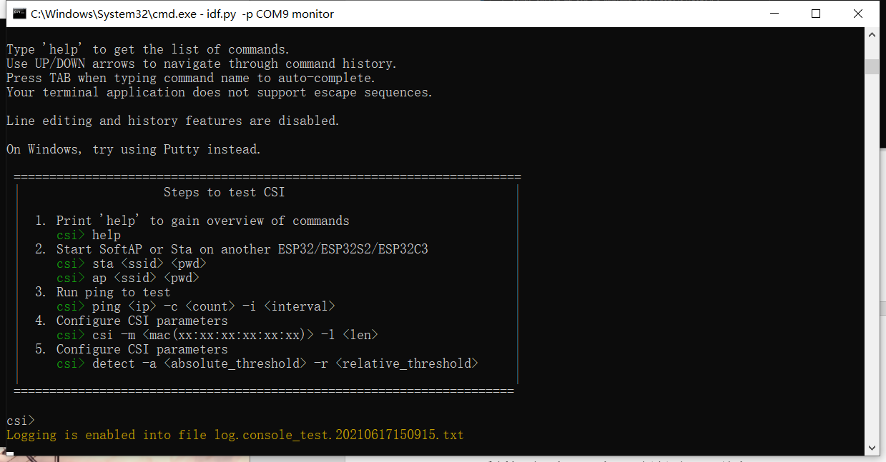

csi >sta csi_softap # connect to AP

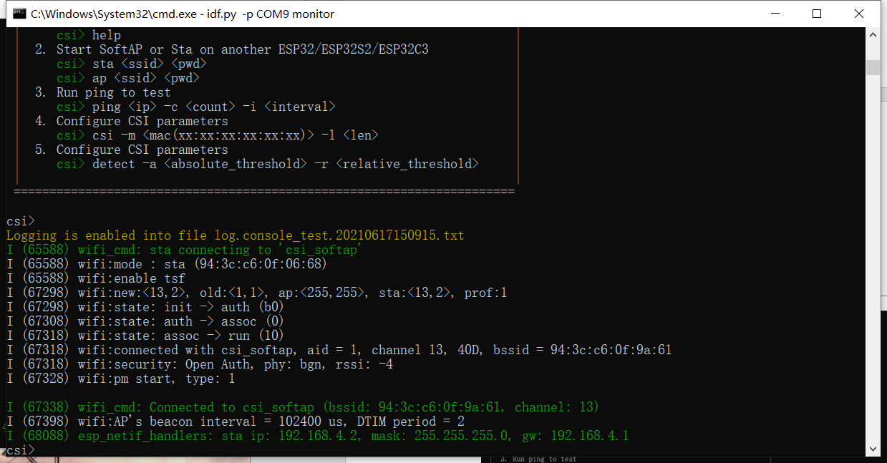

### 2.3.3 Print CSI log

csi >csi -o # Get CSI_DATA log

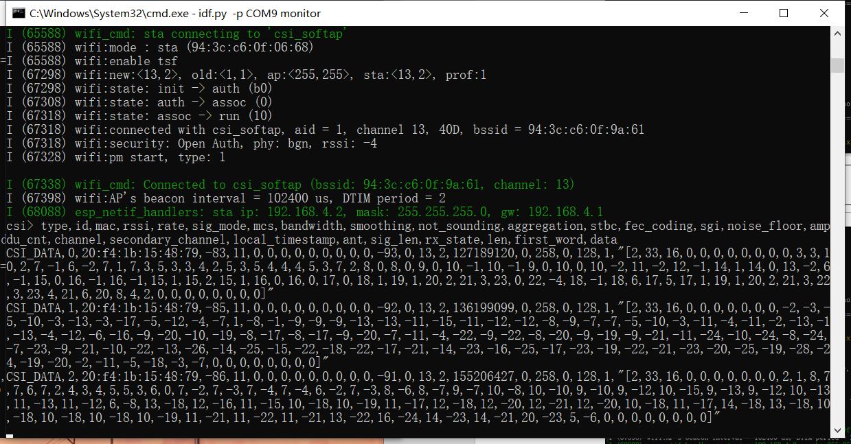

Enter Ctrl+T to open the interface and Ctrl+L to stop the log acquisition.

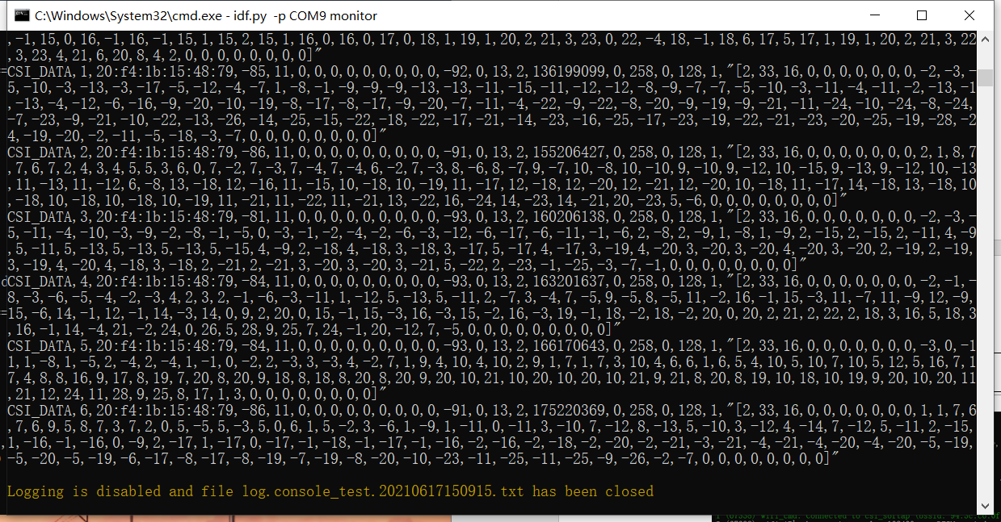

Enter Ctrl+] to exit the serial port mode, and the log is saved in the console_test directory.

